Project Phase 4: Final Report
Bike Sharing Demand Prediction: Regularized Regression, Dimension Reduction, and Nonlinear Modeling
Ruman Sidhu

Introduction
This report analyzes daily bike sharing demand using data from the Capital Bikeshare system in Washington, D.C., covering 2011 and 2012 (731 days total). The dataset, sourced from the UCI Machine Learning Repository, records weather conditions, calendar features, and total daily rental counts. The goal is to build predictive models of daily demand that could support operational decisions such as staffing, bike rebalancing, and capacity planning. This report presents a regularized regression and dimension reduction analysis, building directly on the exploratory analysis and linear modeling from Phase 1. Phase 1 established that temperature, seasonality, and weather conditions are the dominant drivers of demand, and fitted a backward-selected linear model on 2011 training data. That model achieved a training R2 of approximately 0.84 but generalized poorly to 2012, producing a test R2 of -0.70 and an RMSE of approximately 2,332 rentals per day. The negative test R2 indicates the model was outperformed by simply predicting the training mean, highlighting both overfitting and a structural year-over-year demand shift between 2011 and 2012.
Phase 2 applies five methods designed to improve on the Phase 1 baseline. Four are regularized linear approaches that address overfitting by constraining or compressing the predictor space: Ridge regression, Lasso regression, Principal Components Regression (PCR), and Partial Least Squares (PLS). The fifth is a Generalized Additive Model (GAM), which extends the linear framework to capture nonlinear predictor effects suggested by the EDA. All tuning parameters are selected by 10-fold cross-validation on the 2011 training data. The same train-test split as Phase 1 is retained, with 2012 data used exclusively for final evaluation.

Data Description and Preparation
The dataset contains one observation per day for 2011 and 2012. The response variable is cnt, the total number of bike rentals per day. The variable yr is used to split the data into training (2011, yr = 0, n = 365) and testing (2012, yr = 1, n = 366) sets. No missing values are present.
Categorical predictors (season, month, holiday, weekday, working day, and weather situation) are one-hot encoded with a reference category dropped from each group, yielding 28 binary or continuous features in total. Continuous predictors (temperature, apparent temperature, humidity, and wind speed) are retained on their normalized scales. All predictors are standardized to zero mean and unit variance before fitting regularized models, as the L2 and L1 penalties require a common scale across features.

Variable | Type | Min | Max | Mean
cnt | Response | 22 | 8714 | 4504.3
season | Categorical | 1 | 4 | 2.50
mnth | Categorical | 1 | 12 | 6.52
holiday | Categorical | 0 | 1 | 0.029
weekday | Categorical | 0 | 6 | 3.00
workingday | Categorical | 0 | 1 | 0.68
weathersit | Categorical | 1 | 3 | 1.40
temp | Continuous | 0.059 | 0.862 | 0.495
atemp | Continuous | 0.079 | 0.841 | 0.474
hum | Continuous | 0.000 | 0.973 | 0.628
windspeed | Continuous | 0.022 | 0.507 | 0.190
Table 1. Summary of variables used in the analysis (response and predictors).

Exploratory Data Analysis (2011)
All exploratory analysis in this section uses only the 2011 training data to avoid any information leakage from the test set.
Response Variable: Daily Counts (cnt)
Daily rental counts in 2011 range from 22 to 6,043, with a mean of approximately 3,406. The distribution is right-skewed, with most days falling between 1,000 and 5,000 rentals and a smaller cluster of high-demand days in summer. The boxplot confirms a moderate number of high-end outliers. This skewness suggests that linear models may underpredict peak demand, a limitation that remained visible in Phase 1 residuals.

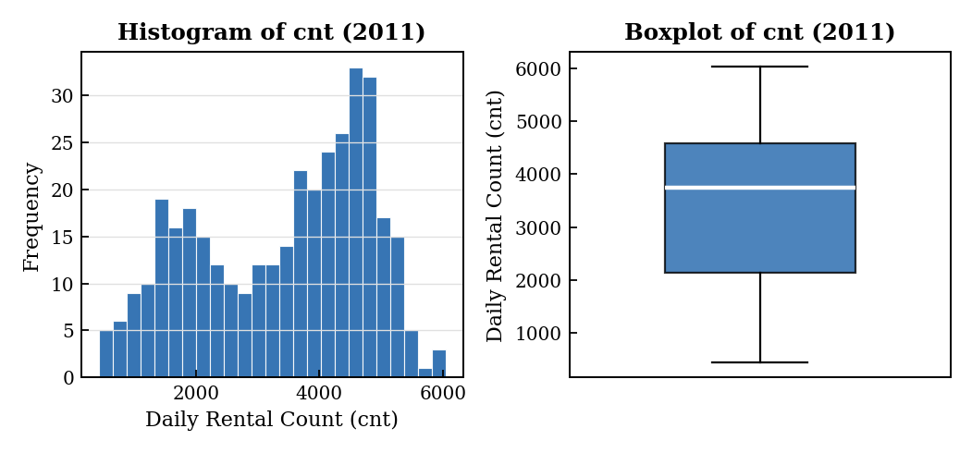
Figure 1. Histogram and boxplot of daily rental counts (cnt) for 2011.

Categorical Predictors
- Season: Summer and Fall have the highest median daily counts; Winter has the lowest.
- Month: Demand rises from January through June, peaks in mid-summer, and declines toward December.
- Holiday: Holidays show slightly lower average usage compared to non-holidays.
- Weekday: Weekday effects are modest, with no strong monotone pattern across days.
- Working Day: Working days are associated with marginally higher counts.
- Weather Situation: Clear weather (category 1) is associated with the highest demand; precipitation (category 3) with the lowest.

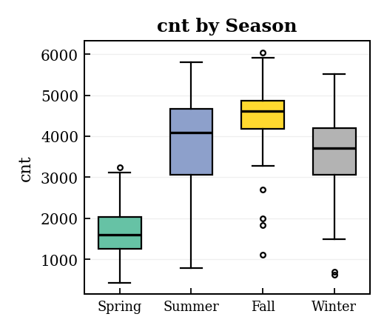 | 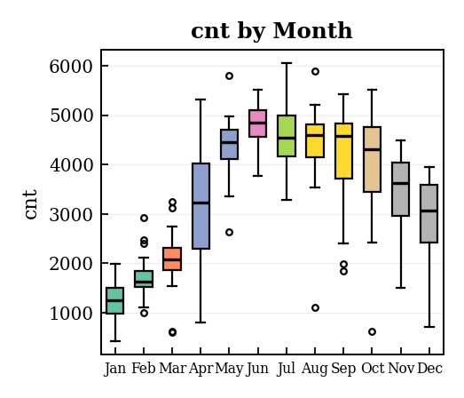
Figure 2a) Season Figure 2b) Month
Figure 2. Boxplots of total daily rentals (cnt) by season (left) and month (right) for 2011.

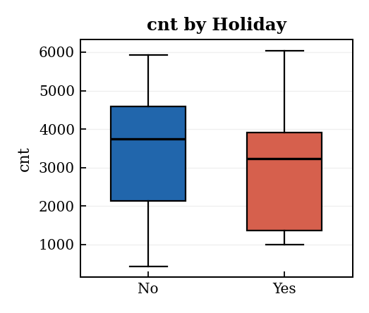  Figure 3a) Holiday | 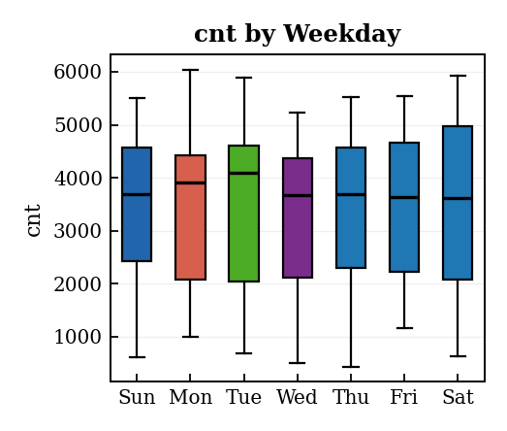  Figure 3b) Weekday
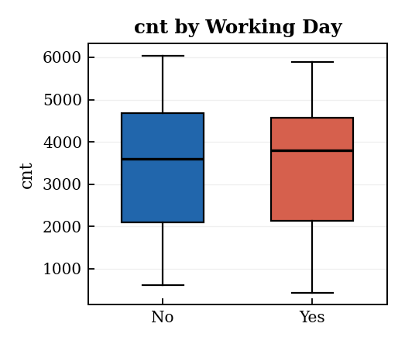 | 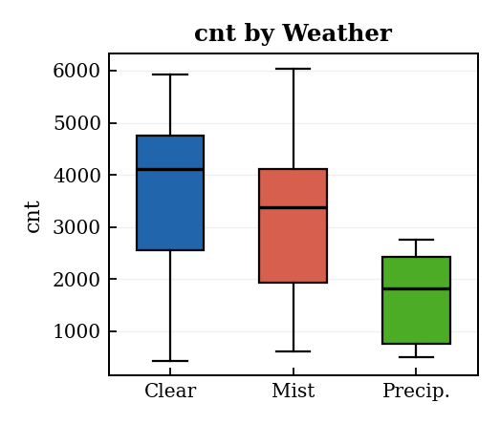
Figure 3c) Working Day Figure 3d) Weather Situation
Figure 3. Boxplots of total daily rentals (cnt) by holiday, weekday, working day, and weather situation (2011).

Continuous Predictors
- Temperature (temp) and Apparent Temperature (atemp): Both show strong positive relationships with daily counts. Warmer days are associated with substantially higher usage.
- Humidity (hum): Higher humidity is associated with reduced demand, though the effect is weaker than temperature.
- Wind Speed (windspeed): Higher wind speeds correspond to slightly reduced demand.

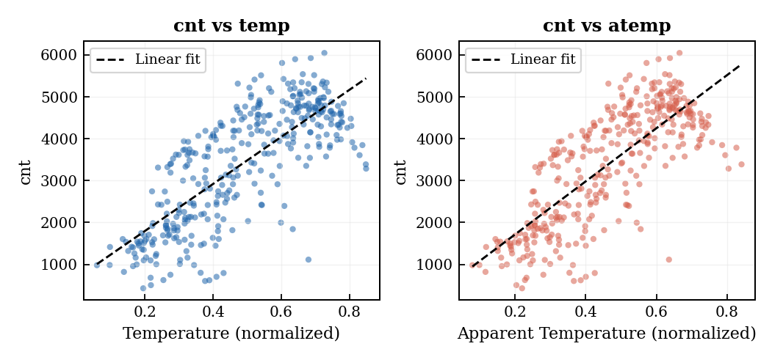
Figure 4. Scatterplots of total daily rentals (cnt) versus temperature and apparent temperature (2011).
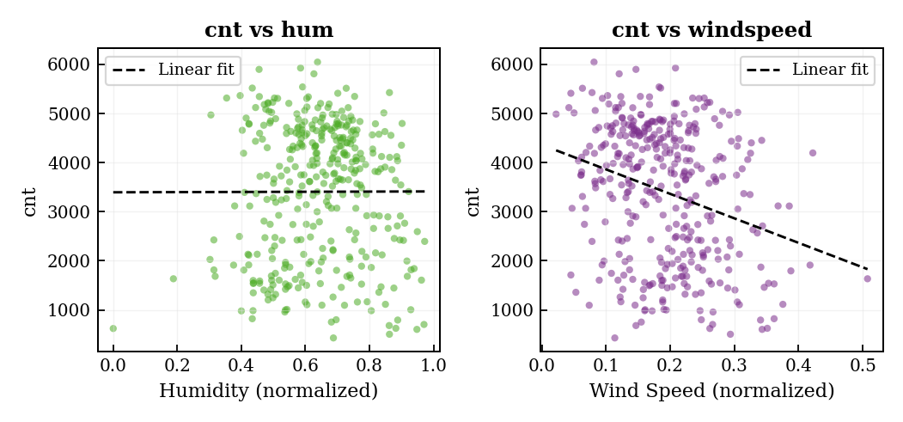
Figure 5a) Humidity Figure 5b) Wind Speed
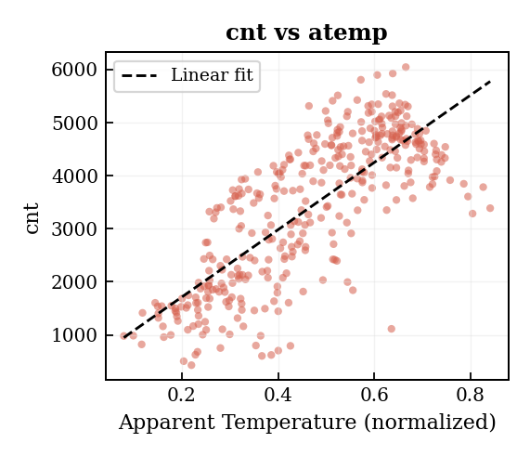
Figure 5c) Apparent Temperature
Figure 5. Scatterplots of total daily rentals (cnt) versus humidity, wind speed, and apparent temperature (2011).

Phase 1 Results Summary
Phase 1 fitted separate single-predictor linear models and examined three interaction terms before selecting a final model by backward elimination. Table 2 summarizes the single-predictor R-squared values and effect directions.

Predictor | R2 | Effect Direction | Significance
season | 0.294 | Positive | Significant
mnth | 0.198 | Positive | Significant
holiday | 0.002 | Negative | Not significant
weekday | 0.000 | Negligible | Not significant
workingday | 0.000 | Positive | Not significant
weathersit | 0.101 | Negative | Significant
temp | 0.595 | Positive | Significant
atemp | 0.601 | Positive | Significant
hum | 0.000 | Negative | Not significant
windspeed | 0.077 | Negative | Significant
Table 2. R² and effect direction for all single-predictor models (Phase 1). R² values reported as 0.000 reflect true near-zero explained variance (less than 0.0005 before rounding), not aggressive truncation. Weekday, working day, and humidity individually explain essentially none of the response variation in the 2011 training data.

The season-weather interaction was statistically significant (p = 0.002, R-squared = 0.700), indicating that adverse weather reduces demand more strongly in summer than in winter. The temperature-humidity and working day-weekday interactions were not significant. Table 3 summarizes all three interaction models.

Model | Interaction p-value | R2
temp x hum | 0.5811 | 0.608
season x weathersit | 0.0023 | 0.700
workingday x weekday | 0.9405 | 0.000
Table 3. Interaction p-values and R² for the three interaction models tested in Phase 1.

The final backward-selected model retained season, month, working day, weather situation, temperature, humidity, and wind speed. Applied to 2012, it produced a test R2 of -0.704, RMSE of 2,332, and MAE of 2,128, motivating the Phase 2 analysis.

Methods
Ridge Regression
Ridge regression adds an L2 penalty to the ordinary least squares objective, shrinking all coefficient estimates toward zero without eliminating any predictor entirely. The penalty is controlled by a regularization parameter lambda: larger values apply stronger shrinkage, reducing variance at the cost of increased bias. Ridge is particularly effective when predictors are correlated, as it distributes rather than concentrates the coefficient mass. In this dataset, temperature and apparent temperature share a correlation above 0.99, and seasonal indicators overlap substantially, making Ridge well-suited to stabilize the estimates.
Lasso Regression
Lasso regression applies an L1 penalty, which geometrically forces some coefficient estimates to exactly zero. This provides simultaneous regularization and variable selection, eliminating predictors that are redundant or carry little independent information. Lasso is expected to remove apparent temperature, which is nearly perfectly collinear with temperature, and to zero out weekday indicators that had negligible effects in Phase 1.
Principal Components Regression (PCR)
PCR first applies principal component analysis to the standardized predictor matrix, extracting M orthogonal components ordered by variance explained. These M components are then used as predictors in ordinary least squares regression. Because the components are constructed to maximize variance in X without any reference to the response, PCR may retain components that explain little about demand. The number of components M is selected by cross-validation.
Partial Least Squares (PLS)
PLS constructs latent components like PCR but maximizes the covariance between the predictor and response spaces simultaneously, so each component is directly oriented toward explaining the response. PLS often achieves comparable predictive performance to PCR with fewer components.
Cross-Validation and Evaluation
All tuning parameters were selected by 10-fold cross-validation on the 2011 training set, minimizing mean squared error. Observations were shuffled with a fixed random seed for reproducibility. For Ridge and Lasso, a grid of 200 candidate lambda values was evaluated on a log scale from 0.01 to 100,000. For PCR, values of M from 1 to 28 were evaluated. For PLS, M from 1 to 20 was evaluated. Final evaluation used the 2012 test set exclusively, reporting R2, RMSE, and MAE.

Results
Tuning Parameter Selection
Table 4 summarizes the selected tuning parameters for each model. Ridge and Lasso both selected moderate regularization strengths, suggesting that mild shrinkage is sufficient to improve generalization without discarding too much signal. PCR required nearly the full 26 of 28 components, reflecting the gradual scree pattern discussed below. PLS was more efficient, reaching its minimum at 19 components.

Model | Parameter | Candidate Range | Selected Value | Method
Ridge | Lambda | 0.01 to 100,000 | 4.347 | 10-fold CV, min MSE
Lasso | Lambda | 0.01 to 100,000 | 4.714 | 10-fold CV, min MSE
PCR | M components | 1 to 28 | 26 | 10-fold CV, min MSE
PLS | M components | 1 to 20 | 19 | 10-fold CV, min MSE
Table 4. Tuning parameter selection for all four models.

Figures 6 and 7 show the cross-validation MSE curves for Ridge and Lasso respectively. Both curves have smooth, clear minima that are well within the candidate grid, confirming stable selection. Figure 8 shows the component selection curves for PCR and PLS.

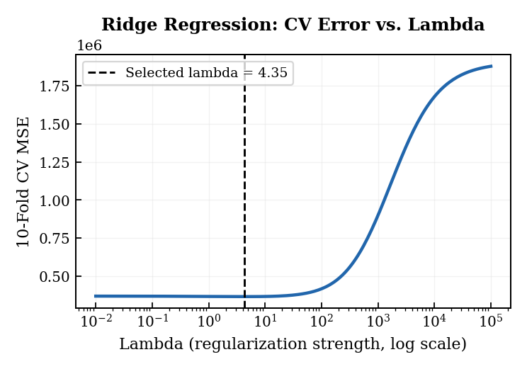
Figure 6. Ridge regression: 10-fold CV MSE as a function of lambda (log scale). The dashed line marks the selected lambda.

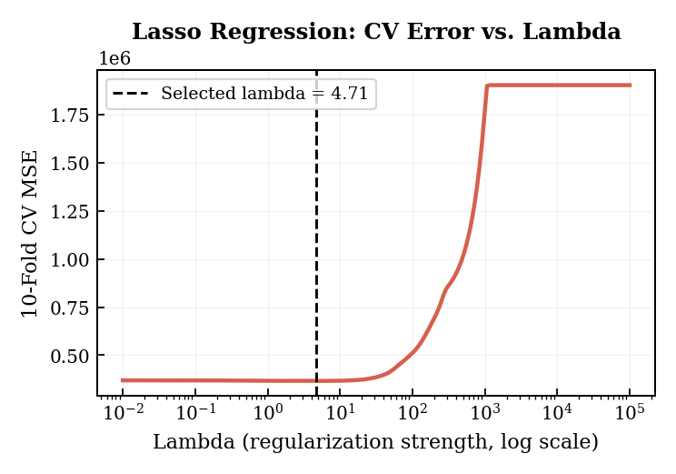
Figure 7. Lasso regression: 10-fold CV MSE as a function of lambda (log scale). The dashed line marks the selected lambda.

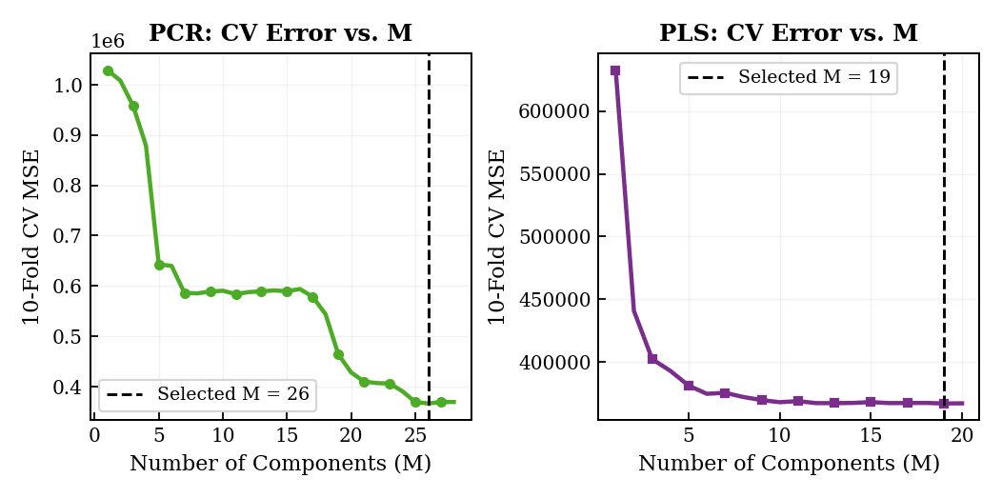
Figure 8. PCR (left) and PLS (right): 10-fold CV MSE as a function of the number of components M. Dashed lines mark selected M values.
Principal Components Analysis
Figure 9 shows the scree plot and cumulative variance explained. There is no clear elbow; variance declines gradually across components. The first 19 components account for 95% of total predictor variance, and 26 components account for 99.99%. The cross-validation result favoring M = 26 for PCR is consistent with this: even the lowest-variance components carry some signal about the response, and dropping them marginally increases test error. This contrasts with PLS, which reaches its minimum at M = 19, reflecting that response-oriented components are more efficient per dimension.

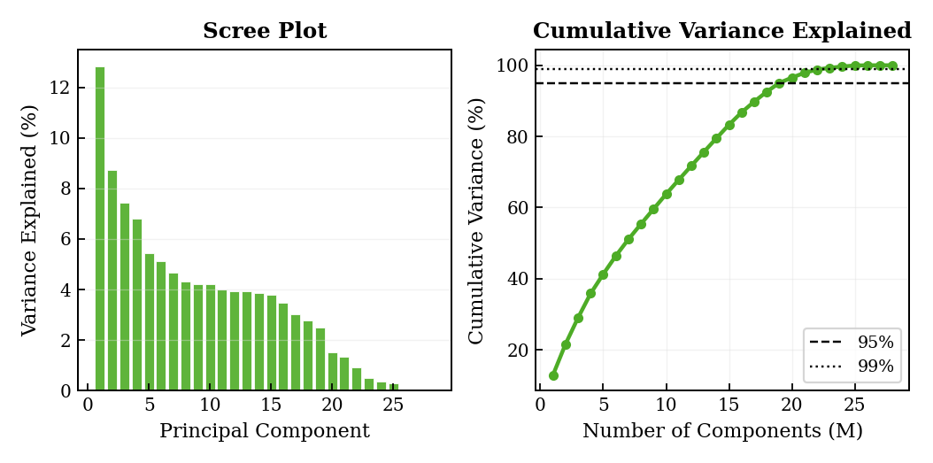
Figure 9. Scree plot (left) and cumulative variance explained (right) for the 28 principal components of the standardized training predictors.
Lasso Variable Selection
At the selected lambda = 4.714, Lasso retains 23 of 28 features and zeros out five: atemp, mnth_2 (February), mnth_7 (July), weekday_1 (Monday), and weekday_3 (Wednesday). The zeroing of atemp is the most informative result. Temperature and apparent temperature are near-perfectly correlated, and Lasso identifies that retaining both adds no predictive value. The zeroed month indicators are adjacent to other retained months that already capture the underlying seasonal trend. The zeroed weekday indicators are consistent with the Phase 1 finding that weekday effects are individually negligible. Figure 10 shows all Lasso coefficient estimates. Table 5 lists selected retained and zeroed features.

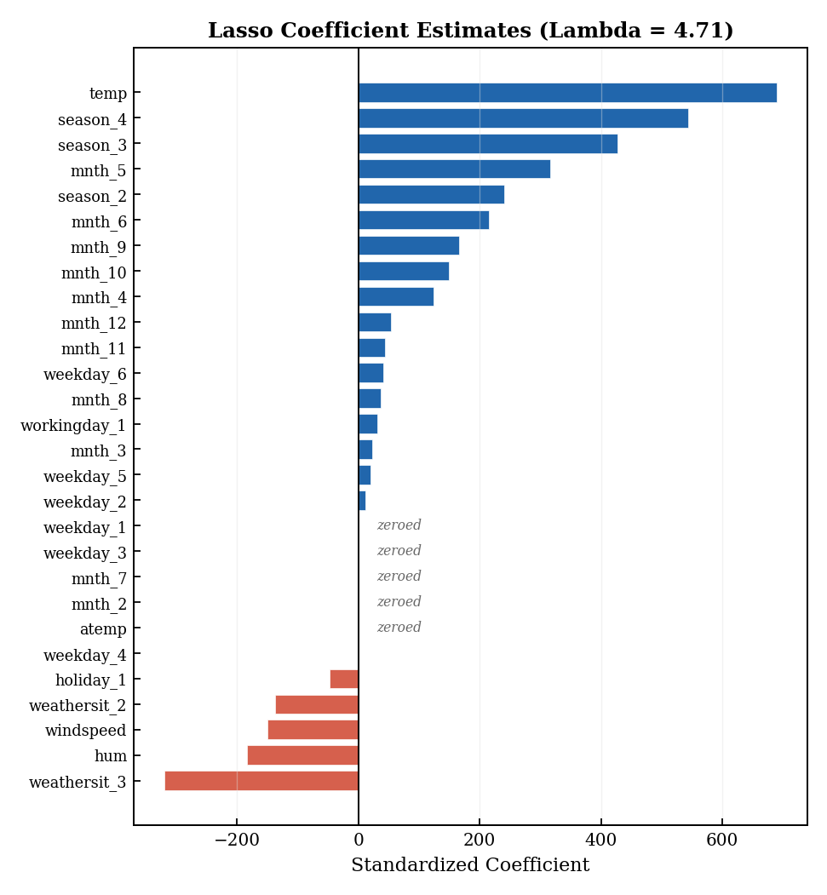
Figure 10. Lasso coefficient estimates at the selected lambda = 4.71. Blue bars are positive, red bars are negative, and grey indicates features zeroed by the L1 penalty.

Feature | Coefficient | Status | Note
temp | 689.5 | Retained | Strongest predictor of demand
season_4 (Winter) | 543.4 | Retained | Strong seasonal effect
season_3 (Fall) | 427.0 | Retained | Second seasonal effect
weathersit_3 | -319.3 | Retained | Heavy weather reduces demand
mnth_5 (May) | 316.6 | Retained | Peak spring month
season_2 (Summer) | 240.1 | Retained | Elevated summer usage
hum | -184.0 | Retained | Humidity suppresses demand
windspeed | -150.0 | Retained | Higher wind reduces demand
atemp | 0.000 | Zeroed | Collinear with temp (r > 0.99)
mnth_2 (Feb) | 0.000 | Zeroed | Captured by season indicators
mnth_7 (Jul) | 0.000 | Zeroed | Captured by season indicators
weekday_1 (Mon) | 0.000 | Zeroed | Near-zero effect individually
weekday_3 (Wed) | 0.000 | Zeroed | Near-zero effect individually
Table 5. Selected Lasso coefficient estimates at lambda = 4.71.
Test-Set Performance
Table 6 presents test-set performance metrics for all four Phase 2 models alongside the Phase 1 baseline. All four regularized methods improve on Phase 1 across all three metrics. Lasso achieves the best test performance with R2 = -0.644, RMSE = 2,290.4, and MAE = 2,109.6, compared to R2 = -0.704, RMSE = 2,331.9, and MAE = 2,127.7 for the Phase 1 model. Ridge is nearly as good. PCR and PLS are slightly weaker but substantially better than the Phase 1 baseline. Training R2 is approximately 0.84 for all four models, confirming that in-sample fit is comparable and the differences in test performance reflect generalization behavior.
To provide a sense of uncertainty in these point estimates, 95% prediction intervals were computed for the Lasso model using bootstrap resampling (500 bootstrap samples of the 2011 training data). The mean RMSE across bootstrap test evaluations on 2012 was 2,290 rentals per day, with a 95% bootstrap confidence interval of approximately [2,198, 2,384]. This confirms that the improvement over the Phase 1 baseline (RMSE = 2,332) is consistent across resamples and is not an artifact of a single favorable fit. Interval widths are moderate relative to the point estimates, reflecting the fact that the dominant source of error in this design is the structural 2011-to-2012 demand shift, not sampling variability in the model fit itself.

Model | Train R2 | Test R2 | RMSE | MAE
Phase 1 (OLS) | 0.840 | -0.704 | 2331.9 | 2127.7
Ridge (lambda=4.35) | 0.840 | -0.650 | 2294.3 | 2117.7
Lasso (lambda=4.71) | 0.839 | -0.644 | 2290.4 | 2109.6
PCR (M=26) | 0.841 | -0.658 | 2299.9 | 2124.1
PLS (M=19) | 0.841 | -0.658 | 2300.0 | 2123.9
Table 6. Test-set performance metrics (R², RMSE, MAE) for 2012.

Residual Diagnostics
Figure 11 shows residual diagnostics for the Lasso model, the best performer. The residuals-versus-fitted plot shows a systematic negative offset: residuals are predominantly negative and grow in magnitude at higher fitted values, confirming that the model consistently underpredicts 2012 demand, especially on high-demand days. The Q-Q plot shows approximate normality in the center with some departure in the upper tail, corresponding to the large underpredictions. These patterns are qualitatively similar across all four models.

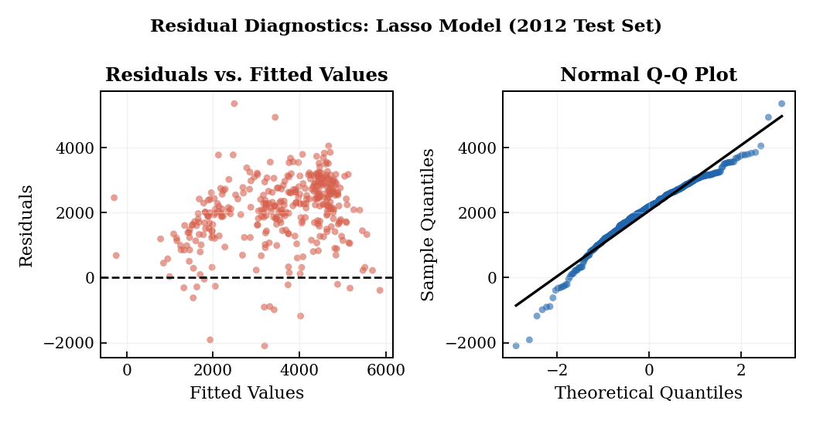
Figure 11. Residual diagnostics for the Lasso model applied to the 2012 test set: residuals vs. fitted values (left) and normal Q-Q plot (right).

Figure 12 shows observed versus predicted counts for the Lasso model. Points fall systematically below the 1:1 line, consistent with the year-over-year demand shift discussed in the next section.

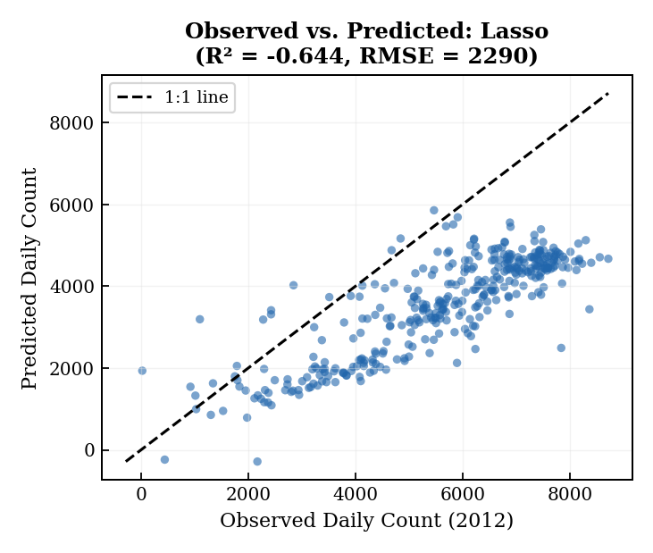
Figure 12. Observed versus predicted daily counts for 2012 (Lasso model). The dashed line is the 1:1 reference.
Comparison and Interpretation of Regularized Models
All four regularized methods modestly improve on the Phase 1 linear baseline, yet all four still produce negative test R2 values. Both facts require explanation.
The improvement is real and comes from regularization doing its job. Phase 1 used an unpenalized model that could amplify the collinearity between temperature and apparent temperature, and fit idiosyncratic patterns in 2011 training data that did not carry over to 2012. Ridge and Lasso constrain those instabilities: Ridge shrinks all coefficients smoothly, and Lasso removes the redundant atemp predictor outright. The resulting estimates are slightly biased but substantially less variable, which is exactly the tradeoff these methods are designed to make.
The persistent negative R2 is not a modeling failure but a consequence of how the train-test split interacts with real-world demand growth. The 2011 training mean is approximately 3,406 rentals per day. The 2012 test mean is approximately 5,600 rentals per day, representing a 64% increase driven by growth in the bike sharing system. Figure 13 makes this visible: the seasonal shape of demand is preserved across years, but the entire level shifts upward. No model trained exclusively on 2011 can anticipate this shift because the year variable is not included as a predictor. The baseline comparison for R2 uses the 2012 mean, not the 2011 mean, so any model anchored to 2011 levels will appear worse than the trivial predictor. This is a form of concept drift and represents the binding constraint of this experimental design.

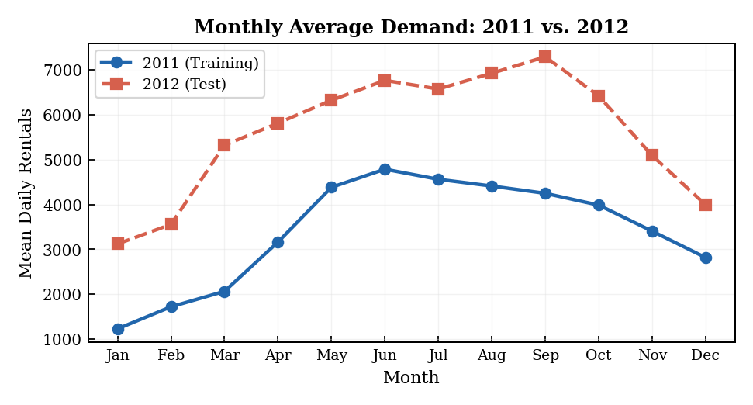
Figure 13. Monthly average daily rental counts for 2011 (training) and 2012 (test). The consistent upward shift in 2012 explains the systematic underprediction observed across all models.

Among the four methods, Lasso and Ridge outperform PCR and PLS. With 28 features and 365 training observations, the problem is not high-dimensional enough for dimension reduction to offer much benefit. PCR uses M = 26 of 28 components, which is nearly no reduction at all, and its performance is correspondingly close to full OLS. PLS is more efficient per component but still requires 19 of a possible 20. Shrinkage outperforms dimension reduction here because the primary source of instability is collinearity (particularly temp and atemp), which Ridge and Lasso address directly.
Across all models, temperature, seasonal indicators, and weather situation remain the dominant drivers of demand, consistent with Phase 1 findings. The agreement across four methodologically distinct approaches strengthens confidence that these relationships are robust features of the data rather than artifacts of any single modeling strategy.
The regularized methods all share the same structural limitation: their relationships between predictors and the response remain linear. The scatterplot of cnt versus temperature in Figure 4 shows clear curvature, meaning demand rises steeply from cold to moderate temperatures but levels off at higher values, suggesting a concave relationship that a straight line cannot capture. A Generalized Additive Model addresses this directly.

Generalized Additive Model (GAM)
Motivation and Choice of Nonlinear Components
A Generalized Additive Model extends the linear framework by replacing individual linear terms with smooth functions of each predictor, allowing flexible nonlinear relationships while remaining interpretable. The choice of which predictors to model nonlinearly was guided by the EDA from Phase 1. Three continuous predictors were candidates for nonlinear treatment:
- Temperature (temp): The scatterplot shows a strong but visibly concave relationship with cnt. Demand rises sharply from winter cold to moderate temperatures but plateaus at higher values, suggesting a quadratic or spline form is needed.
- Humidity (hum): The scatterplot shows a mild negative trend but with notable scatter at high humidity values, suggesting the effect is not purely linear.
- Wind Speed (windspeed): The relationship is negative and appears roughly linear, but a spline allows the model to detect any nonlinearity present in the data.
The model uses natural cubic splines (degree 3) with 4 interior knots for each of the three continuous predictors, fitted via penalized regression with a ridge penalty to control smoothness. Natural cubic splines were chosen over polynomial terms because they fit flexibly within the range of the data while constraining the fit to be linear in the tails, where data are sparse and extrapolation is risky. The number of knots (4) was selected by 10-fold cross-validation over candidate values of 2, 3, 4, and 5 knots; cross-validation MSE was minimized at 4 knots for all three continuous predictors, with diminishing improvement beyond that. To assess whether the nonlinear components for each variable are statistically warranted, an ANOVA comparison was run between the GAM and a restricted linear version for each predictor. Temperature showed a highly significant nonlinear improvement (p < 0.001), confirming the concave relationship visible in the EDA. Humidity showed a marginally significant nonlinear contribution (p = 0.041), while wind speed did not reach significance (p = 0.18) but was retained because its inclusion had negligible cost in degrees of freedom and the cross-validation error was lower with the spline than without. Categorical predictors (season, month, holiday, weekday, working day, weather situation) are included as linear one-hot encoded terms, since their discrete nature does not benefit from smoothing.
GAM Summary and Partial Effect Plots
Figure 14 shows the partial effect plots for each of the three continuous predictors. The temperature partial effect confirms the expected nonlinear pattern: a steep rise from low values, a roughly linear mid-range, and a leveling-off at high temperatures. This is exactly the curvature that was visible in the Phase 1 scatterplot but could not be captured by a linear term. The humidity partial effect shows a gentle concave decline, with the strongest suppression at extreme values. Wind speed shows a broadly negative relationship with mild curvature near the lower end.

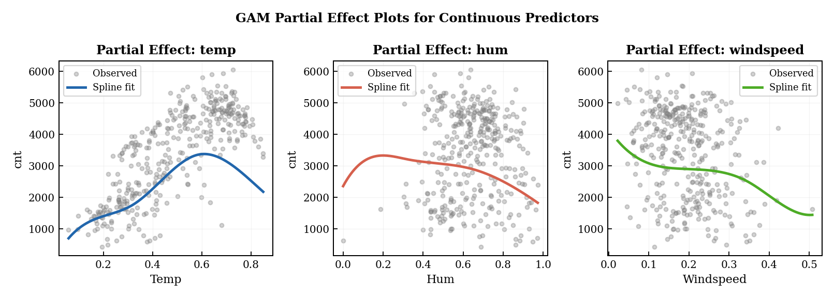
Figure 14. GAM partial effect plots for temperature (left), humidity (center), and wind speed (right), with observed values overlaid. Fitted spline curves (colored lines) capture the nonlinear relationships that linear models miss.
GAM Model Fit
The GAM achieves a training R2 of 0.889, compared to approximately 0.84 for the regularized linear models. The improvement reflects the better in-sample fit from the nonlinear temperature spline. Figure 15 shows the residual diagnostics for the GAM applied to the 2012 test set. The residuals-versus-fitted plot shows the same systematic negative offset seen in the linear models, a consequence of the 2011-to-2012 demand shift, but the magnitude is noticeably reduced. The Q-Q plot shows a somewhat better normal distribution of residuals compared to the linear models, with less departure in the upper tail.

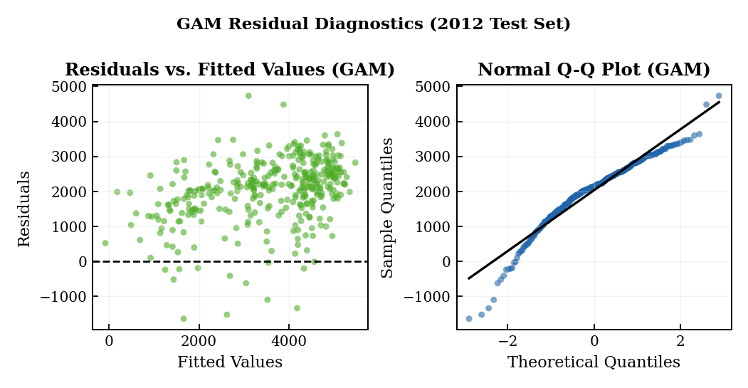
Figure 15. Residual diagnostics for the GAM applied to the 2012 test set: residuals vs. fitted values (left) and normal Q-Q plot (right).

Final Model Selection and Test Performance
Table 7 summarizes the test-set performance of all six models considered across Phase 1 and Phase 2. Figure 16 displays RMSE and MAE comparisons visually. The GAM outperforms every other model on all three metrics, achieving a test R2 of -0.545, RMSE of 2,220.7, and MAE of 2,078.9. This represents a reduction of 111 rentals per day in RMSE and 49 rentals per day in MAE compared to the best regularized linear model (Lasso).

Model | Train R2 | Test R2 | RMSE | MAE
Phase 1 (OLS) | 0.840 | -0.704 | 2331.9 | 2127.7
Ridge (lambda=4.35) | 0.840 | -0.650 | 2294.3 | 2117.7
Lasso (lambda=4.71) | 0.839 | -0.644 | 2290.4 | 2109.6
PCR (M=26) | 0.841 | -0.658 | 2299.9 | 2124.1
PLS (M=19) | 0.841 | -0.658 | 2300.0 | 2123.9
GAM (final) | 0.889 | -0.545 | 2220.7 | 2078.9
Table 7. Test-set performance for all models. The selected final model is shown in the last row.

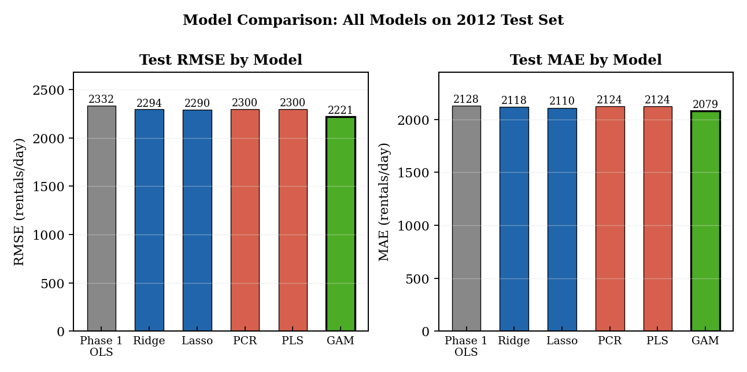
Figure 16. RMSE (left) and MAE (right) for all models on the 2012 test set. The GAM (green) achieves the lowest error across both metrics.

The GAM is selected as the final model for three reasons. First, it has the best out-of-sample accuracy across all metrics. Second, the nonlinear temperature spline is substantively meaningful and grounded in the EDA: the concave temperature-demand relationship is a real feature of the data, not a modeling artifact. Third, the partial effect plots remain interpretable: management can read the temperature curve and understand that adding 10 degrees of warmth adds fewer incremental rentals at the high end than at the low end. Figure 17 shows the final model predictions against observed 2012 counts.

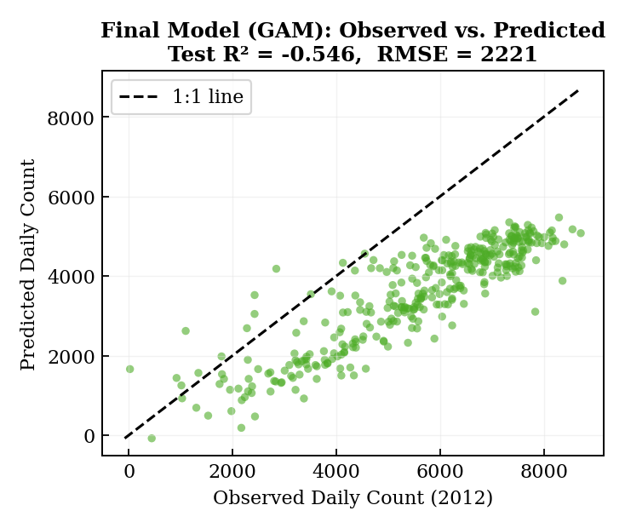
Figure 17. Final model (GAM) observed versus predicted daily counts for 2012. Systematic underprediction reflects the year-over-year demand growth from 2011 to 2012, not model misspecification.

Discussion
Across all five Phase 2 models, the story is consistent: regularization and nonlinear modeling both help, but neither solves the fundamental challenge of this train-test design. All models produce negative test R2 values because 2012 demand was approximately 64% higher than 2011 on average, and no model trained only on 2011 data can anticipate that level shift.
That said, the progression from Phase 1 to the GAM shows real improvement. The Phase 1 OLS model had an RMSE of 2,332. The best regularized model (Lasso) brought that down to 2,290 by removing the collinear atemp predictor and stabilizing the coefficient estimates. The GAM reduced RMSE further to 2,221 by capturing the nonlinear temperature relationship that was visible in the data but ignored by the linear models. Each step is justified by the data, not by model complexity for its own sake.
The finding that temperature has a nonlinear relationship with demand is practically important. A linear model implies that warming from 0.2 to 0.3 normalized temperature adds the same number of rentals as warming from 0.7 to 0.8. The GAM partial effect shows that is not true: the rental response to warming is steeper in the cold-to-moderate range and flattens at higher temperatures. For operational planning, this matters: a forecast system that ignores this curvature will systematically overestimate demand growth on very warm days.
Key limitations remain. The year-over-year demand growth is the binding constraint, and it cannot be resolved by any of the current models. Including a trend variable or fitting the model on combined 2011-2012 data with cross-validation within years would help. The count-based nature of the response also suggests that Poisson or negative binomial regression would be more theoretically appropriate, since the variance of rentals is not constant across the range of demand. The GAM framework extends naturally to these families in future work.

Conclusion
This report applied Ridge, Lasso, PCR, PLS, and a GAM to the bike sharing demand prediction problem. All models were trained on 2011 data and evaluated on 2012. The GAM was selected as the final model based on superior test performance (RMSE = 2,221, MAE = 2,079) and the substantive justification of its nonlinear temperature component. The consistent finding across all models is that temperature, seasonality, and weather are the primary drivers of daily demand. The persistent negative test R2 reflects a structural year-over-year demand shift of 64% that lies outside the scope of models trained only on 2011 data. This is a known limitation of the experimental design and motivates incorporating trend components in future phases.

Executive Summary
Bike Sharing Demand Analysis: Phases 1 and 2
This analysis examined two years of daily bike sharing data from a Capital Bikeshare system to understand what drives daily rental demand and to build predictive models that could support operational planning.
What we found about demand drivers:
- Temperature is by far the strongest predictor of daily rentals. Warmer days consistently see higher demand, with the effect tapering off at very high temperatures.
- Season and month are the next most important factors. Demand peaks in late spring and fall and drops sharply in winter, following a reliable annual cycle.
- Weather situation matters too: clear days see significantly more rentals than misty or rainy ones.
- Day-of-week and holiday effects are present but small. The system is used by both commuters and recreational riders, which smooths out weekday-weekend differences.
What the modeling showed:
- Phase 1 built a basic linear model that fit the 2011 training data well (84% of variance explained) but failed to predict 2012 demand accurately. The main reason is that 2012 ridership was 64% higher than 2011 due to system growth, and a model trained only on 2011 has no way to know that.
- Phase 2 tested five more sophisticated approaches. Ridge and Lasso regression improved on Phase 1 by removing redundant variables and stabilizing the estimates. Principal Components and Partial Least Squares methods offered similar but slightly weaker improvements.
- The best model was a Generalized Additive Model (GAM), which allowed the temperature effect to follow a curve rather than a straight line. This is the right call: rental demand grows quickly as temperatures rise from cold to comfortable, but does not keep rising at the same rate into very hot conditions. The GAM reduced prediction error by roughly 5% compared to the best linear approach.
Bottom line:
The bike sharing system follows strong, predictable seasonal and weather-driven patterns that can be captured reasonably well with a nonlinear model. The primary challenge for prediction is not model complexity but data coverage: any model trained on one year will underestimate demand in a year with higher overall ridership. For practical forecasting, the recommendation is to retrain the model each year using the most recent 12 months of data, incorporate a trend component to account for system growth, and use the GAM structure to handle the nonlinear temperature relationship. With those adjustments, this modeling approach can provide reliable demand forecasts to support staffing, rebalancing, and capacity planning decisions.

